1. **Lambda Expression**:
   1. The most exciting feature in Java8.
   2. The reason is it allows us to write **less code** and helps us to achieve more.
2. 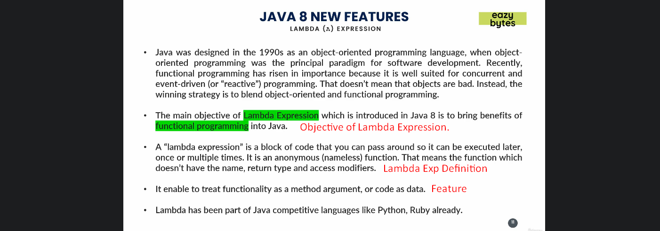
3. With Lambda Expression, you can pass business logic around like you used to pass parameters.
4. You can reduce the # of lines of codes.
5. Using Lambda Expression, we can pass code as value.